NATIONAL INDIAN ARTS AWARDS 2016

NOMINATION FORM

Please fill in the form below to nominate one individual for one of the following three awards:

* **Life Time Achievement in Arts & Education**
* **Distinguished Teachers Award in Music – Acharya Ratna / Sangeet**
* **Distinguished Teachers Award in Dance – Acharya Ratna / Nritya**

**Please note that each candidate needs at least two people to nominate them. This application should be filled out and signed jointly by the nominator and seconder.   
  
The National Indian Arts Awards are only open to residents of the UK. Previous winners of any of the above awards may not be nominated.**

Name of Candidate:  
  
Award being nominated for (one of the above three):

Candidate email:

A synopsis of the candidate’s achievements: (Maximum of 250 words – please submit additional sheet if required)

Joint statement of recommendation by at least two nominators: (Maximum of 249 words – please submit additional sheet if required)

Nominator Details:

**Nominator:** Name, Address & Contact details

Signed: Dated:

**Seconder:**  Name, Address & Contact details

Signed: Dated:

**Please feel free to attach further testimonials.  
  
Once completed, please email completed form to** [**director@milapfest.com**](mailto:director@milapfest.com) **or post to:**

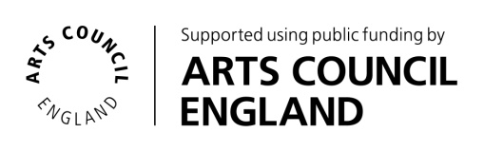**Milapfest  
The Capstone Building  
Liverpool Hope University  
17 Shaw Street  
Liverpool L6 1HP**  
**Applications must be received by no later than July 1st 2016.**